2015 – VectorVest Retirees Income Model Portfolio
The 2015 Retirees Income Model Portfolio (The Retirees) is an automated portfolio intended for educational purposes only. It should not be construed in any way as investment advice for individual stock selection or portfolio management. Please do your own stock analysis and backtesting to develop a trading plan that suits your investment style, financial goals, time horizon and risk tolerance. You will learn more, and chances are you will do better than following an automated model portfolio.
As an individual investor, you have significant advantages over a strictly automated trading system:
- Market Timing – VectorVest teaches that “follow-through” the day after your entry timing signals is received is of utmost importance. Follow-through means the market is rising and your purchase target is rising after the first half hour of trading. If you can’t be at your computer at market open, then you look at the futures (finviz.com; Bloomberg.com; or your brokerage site), and place a ‘Buy on Stop’ order to protect you in case your purchase target opens lower. With your “real money” portfolio, you are not required to place trades if there is no follow-through the next day after the market timing signal is positive. For example, if the Primary Wave is up (PW/Up), the automated 2015 Retirees Income Model Portfolio will make purchases the next day regardless of whether the market opens strongly to the downside.
- Stock Selection – The Retirees will purchase the top stock from the High CI Rising Dividends search if it is not already owned. As an individual investor, before buying any stock you should study the both the weekly and daily stock graphs, study the industry group to ensure that it is a strong group, rising in price, and finally check the stock news and industry group news looking for both positive and negative articles that may affect your decision. VectorVest recommends you buy a stock only if it is rising on the day of purchase.

The 2015 Retirees Trading Plan – Last Revised January 15, 2015
- Goal Statement:
The primary goal of the model portfolio is to achieve capital growth above inflation to allow capital withdrawal for income as required. An annual gain of 9-15% is a reasonable target for 2015 should the Bull Market continue throughout 2015. Only stocks with a history of increasing dividends well above inflation each year will be considered. Current dividend yields equal to or greater than 1.2% and a dividend growth rate of 6% are minimum requirements.

- Investment:
We will start with an initial investment of $100,000 in this portfolio. We will re-invest dividends as opportunities arise when adding new positions to the portfolio during the year.

- Number of Stocks To Hold and Position Sizing:
  - We will buy and maintain a maximum of 10 positions.
  - We will buy odd lots in order to dollar cost average to equal weight as closely as possible the amount of dollars invested in each position. Therefore, starting with $100,000, our initial investment in each stock will be no more than $10,000 after commissions.
  - We will buy up to 3 positions on any single day.
  - We will not repurchase a stock previously owned for at least 31-days after it has been sold.
  - A maximum of 2 stocks per industry group will be purchased.
  - A maximum of 5% of a stock’s average volume will be purchased.

- When To Buy:
  - When the Primary Wave in the trend column is up, (PW/Up), stocks will be purchased the following day until a maximum of 10 holdings is reached.

- What To Buy:
  - Stocks will purchased from the results of the High CI Rising Dividends search, located in the Retirement Folder of UniSearch.
  - The top stock in the search will be purchased unless it is already owned in the portfolio, or unless it is a stock that has been sold within the last 31 days.
  - The portfolio will be dollar weighted, and odd lots will be purchased.
  - Invest average portfolio value for any new purchase.
  - A maximum of 2 stocks per industry group will be held at one time.
  - A maximum of 5% of a stock’s average volume will be purchased.

- When to Sell:
- A Trailing Stop of 15% is triggered, or
- The stock reaches a Target Gain of 30%, or
- The stock reaches a Maximum Loss of 10%.
- Simulate intraday stops.

- Evaluation. The Retirees Trading Plan will be evaluated and updated every quarter as may be deemed necessary.

RESULTS OF BACKTESTING:
Several backtests were conducted during the periods of December 30, 2011 to January 2, 2015. Several timing signals, stop criteria, number of positions, number of purchases in a day and other tests were run. The backtest with the best combination of the following result criteria was selected over tests that had a higher percent gain over the three year period:
  - % Winners - (68.18% Winners for 2015 Retirees)
  - % Gain/Loss - (113.45% over 2012-2015 period for 2015 Retirees)
  - ARR – Annualized Rate of Return - (37.71% ARR for 2015 Retirees)
  - Maximum Drawdown - (8.05% over 2012-2015 period for 2015 Retirees)

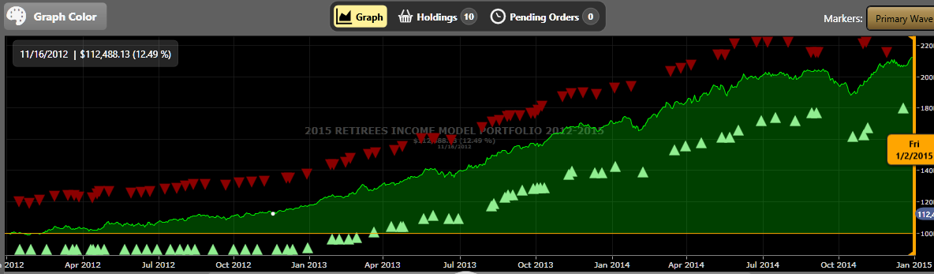
Backtest Results of 2015 Retirees Income Model Portfolio
