Introduction
The purpose of the Business plan is to demonstrate how to use an income portfolio and a growth portfolio to supplement the income of a Canadian retired couple. It is assumed that both are retired and collecting some Canada Pension Plan benefits, Old Age Security and a company pension (many of us do not have this luxury). This may or may not be your case. No attempt has been made regarding government benefit clawback due to high income. Other portfolios such as a tax free savings account are assumed to be used and generate $3,000 income as shown in the cash flow spreadsheet.
I assumed that, as in Dr D’s October 2009 retirement approach, I had $500,000 to generate income, $300,000 would go to dividend income generation and $200,000 would go into a growth portfolio from which 50% of the gains realized in a month would be withdrawn for living expenses. No gains – no income. Fixed income approaches such as bonds or bond ETFs were not considered at this time. Dividends and capital gains both provide tax advantages.
A budget or cash flow spreadsheet was set up to show income and expenses over the course of a year.
A second spreadsheet was set up to track the income from the dividend portfolio.
In both cases the money withdrawn from the portfolios is treated as an interest payment in VV. Cash withdrawals reduce the initial capital investment in the portfolios and distorts the gain calculation.
On December 31 all portfolios were closed. The snips of the portfolio graphs, summary reports and tax reports are in the body of this update, replacing any snips that showed results. From the snips and the accompanying Excel spreadsheets of the budget/cashflow and dividend received you can see how the portfolios performed and check the entries and exits of the trades to see how the signals were used.
Dividend Income
For the dividend income portfolio I selected 5 stocks that have monthly dividends and are selected from the Watchlist Monthly Dividend Payers in the Special Watchlists Folder. Selections are cherry picked from the Monthly Dividend Payers – Phil Search in the Retirement Searches folder.

The Search
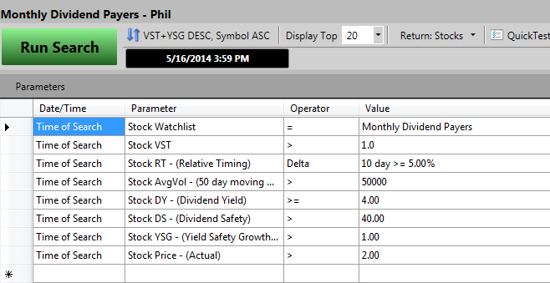

The Portfolio – Parameters

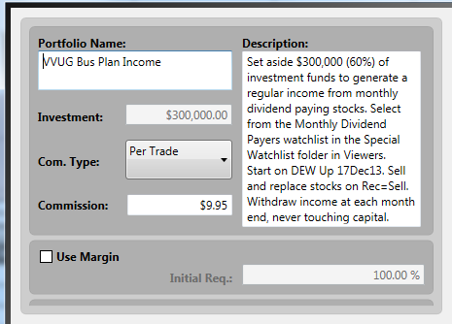

The Portfolio Graph to 31 Dec 2014
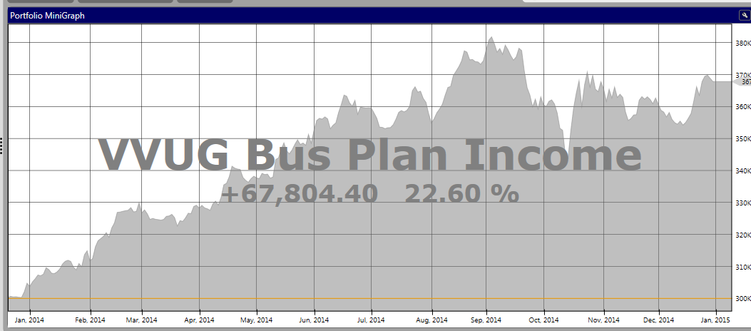

Summary Report to 31 Dec 2014
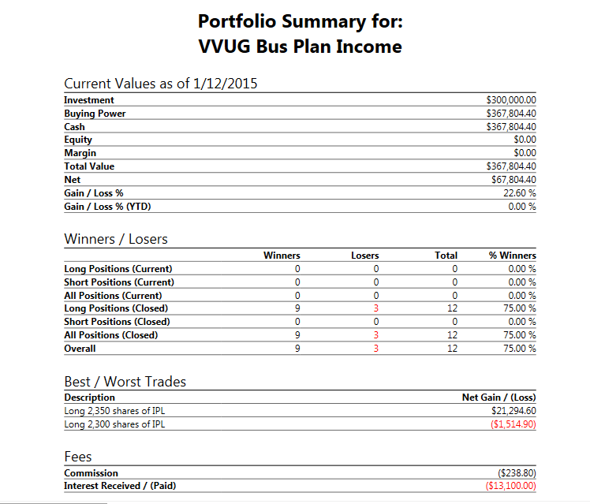

Tax Report For Income Portfolio (showing transactions)

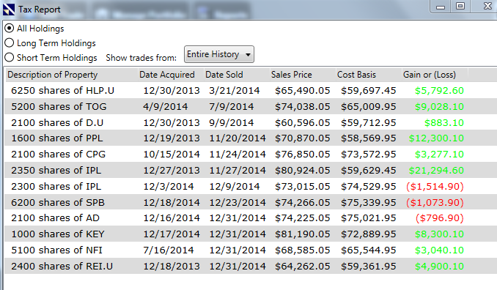

Capital Gains Income – Growth Portfolio
A growth oriented portfolio is used to generate capital growth and income by taking out monthly, 50% of the gains made the current month on any sales. No gain – no income. The approach used is to select from a modified Top VST- Vector Stocks in the Prudent folder. Stocks are cherry picked by looking for rising price and RT that are early in a move up. The stop is Price crossing below EMA Price of 13 or 21 – a judgment call. Start date: 02Jan 2014
The Growth Portfolio Search

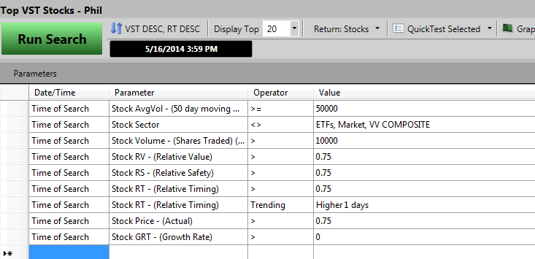

Portfolio Parameters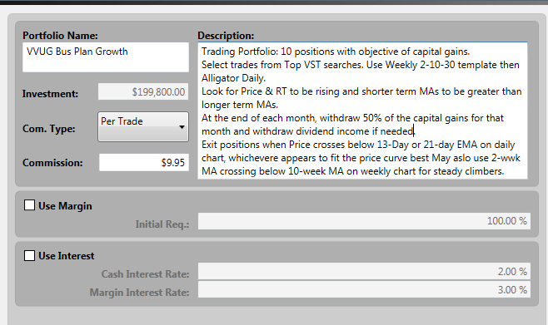

The Growth Portfolio Graph as of 31 Dec 2014

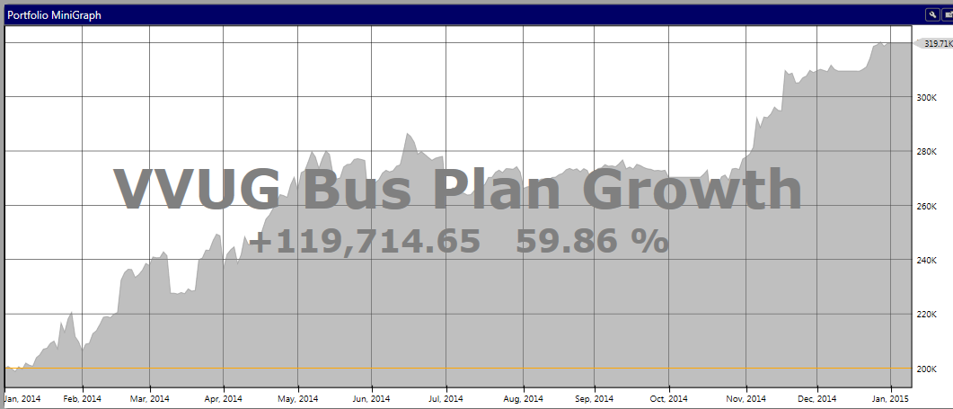

The Growth Portfolio – Summary Report

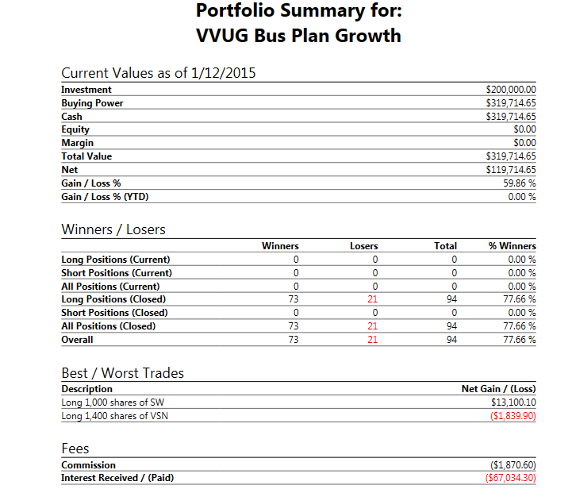

Tax Report for Growth Portfolio

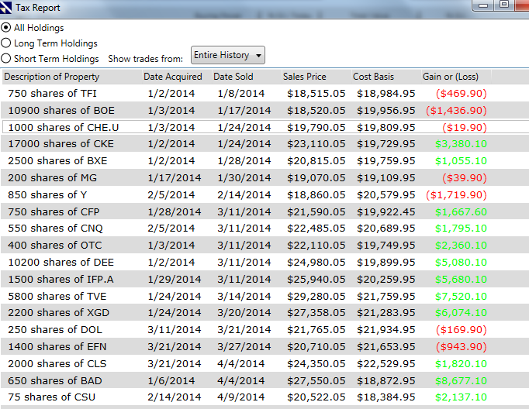
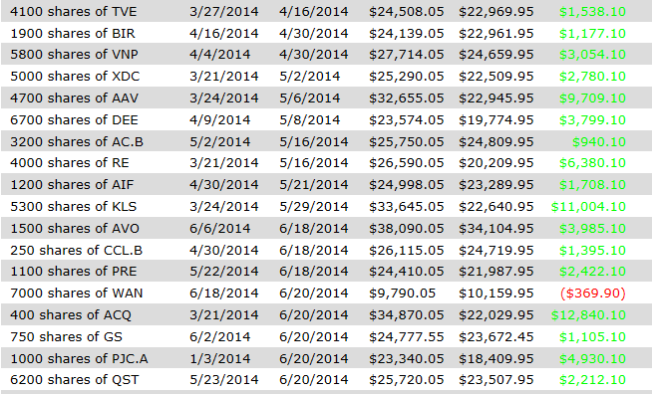
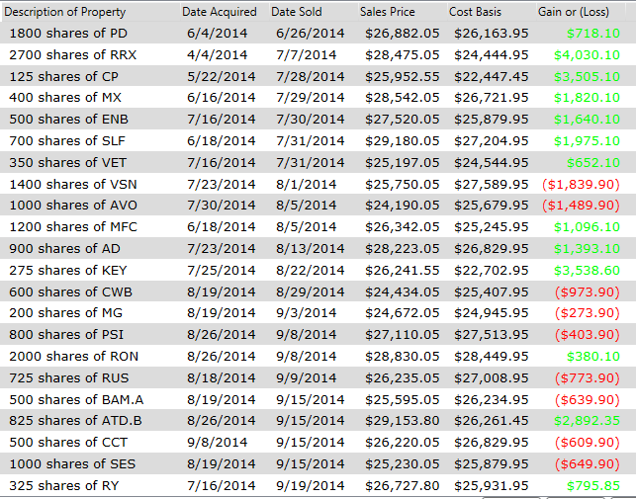
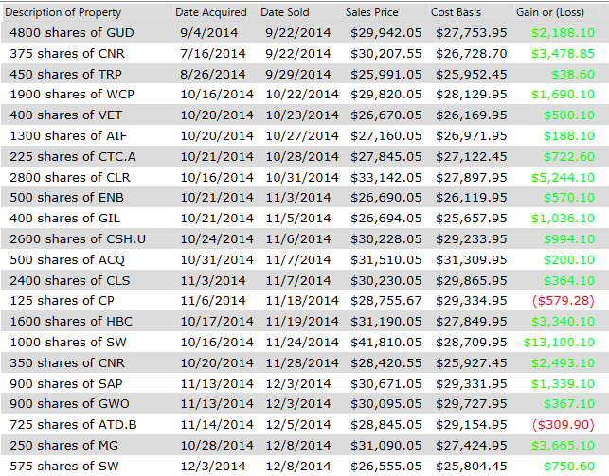
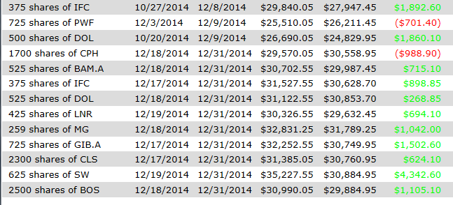

Example of Stock Chart Set Up - Weekly

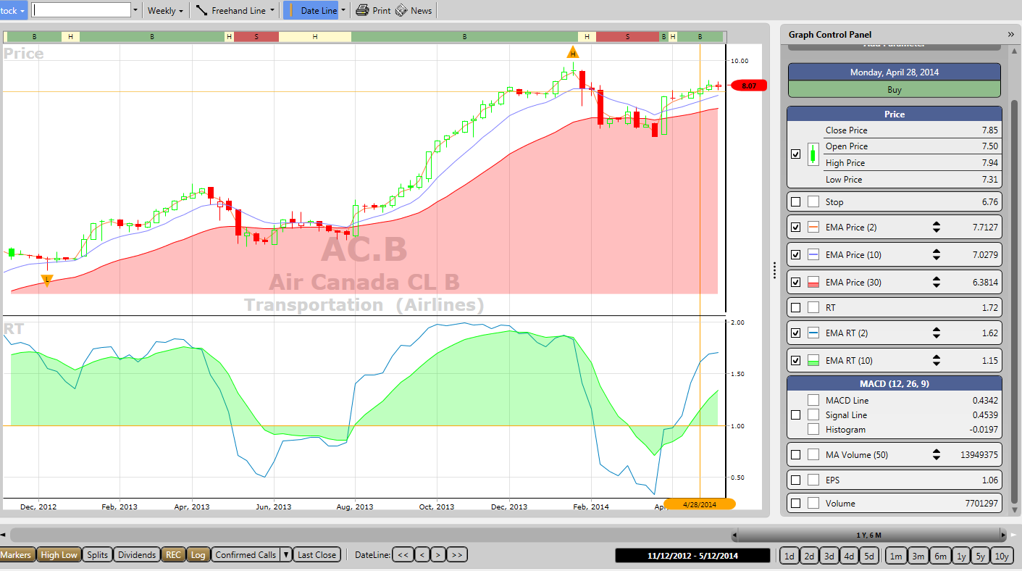

First pass through charts returned from the search is with a weekly template with price EMAs of 2, 10 and 30; and RT EMAs of 2& 10. Log chart type selected. From this short list the daily charts are viewed for final selection of next day’s candidates.

Example of Stock Chart Set Up – Daily

The daily chart has Price and RT EMAs of 5, 8, & 13, a take-off on The William’s Alligator indicator. The EMA 5 should be > than 8 > 13. Offset is not available. The pinch points (circled) are ideal set-ups when the EMAs start to diverge.

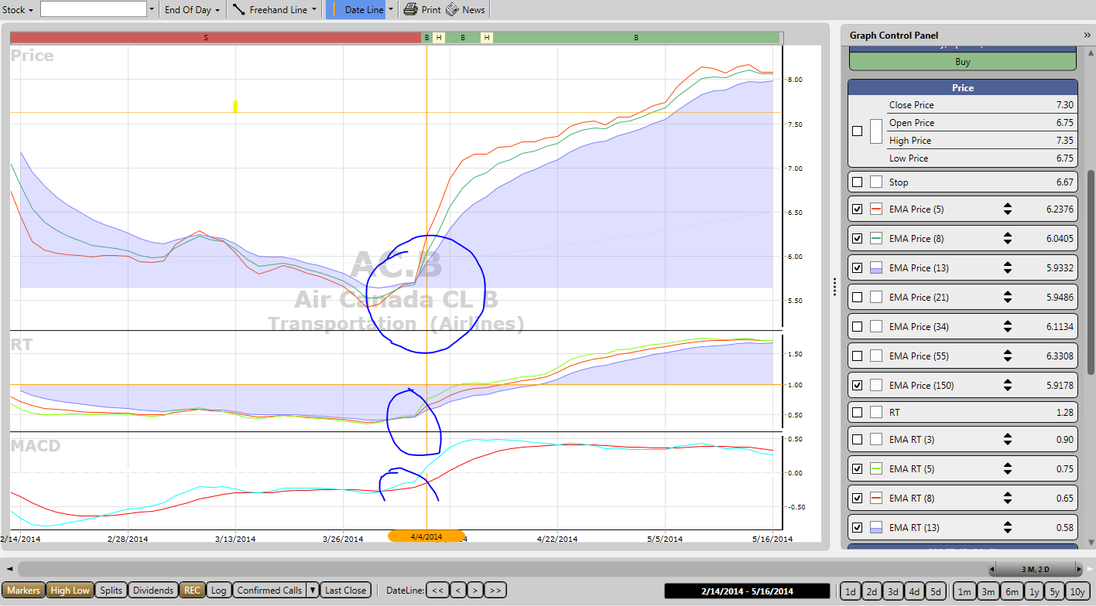

Spreadsheets of income and cash flow or budget are filed separately in MS Excel.

